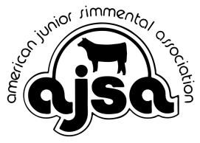
AJSA National Classic Lodging Scholarship Application

The AJSA National Classic Lodging Scholarship is awarded to two AJSA members annually. The scholarship pays the hotel stay costs for one standard room at the National Classic at the hotel headquarters, checking in the first day of Classic activities and checking out the day following Classic conclusion. The scholarship stay covers only the cost of the room and tax. Scholarship recipients are responsible for incidentals and any additional charges. Hotel reservations must be made by the recipient and will be reimbursed following the National Classic. The scholarship is only good for the current year National Classic and is not transferable or refundable in any way.

Application Requirements:
1. Applicants must be a current member of the American Junior Simmental
Association.
2. Applicants must be willing, able, and excited to attend and participate in the
National Classic.
3. Applications must include responses to all questions below and a color photo of the applicant.
4. Applications must be submitted via email to ajsa@simmgene.com no later than
April 15.
5. Winners will be notified no later than April 30.

Name:

AJSA Member Number:
Age as of January 1:

Address:

City, State, Zip:

Phone:
Email:

Number of people in your family expected to attend the National Classic:

Do you have additional family members planning to participate in the National Classic?

2. Provide us with a brief summary of your involvement with the AJSA, your state junior
Simmental association, and the beef industry in general:

3. Why would you like to attend the National Classic?

4. How has your experience in the beef industry had an impact on your life?

6. Why do you feel deserving of this scholarship?

Applicant Signature Parent/Guardian Signature

Date Date

